Test 2

**Problem 1**

For this dataset we did a MANOVA test to test if the mean vectors of all 4 variables were the same for the rootstocks. This yielded a Wilks lambda of 0.154 and a p-value of 7.7e-9 indicating that the means are not the same. For completeness I did a qq plot of the residuals from our model producing:

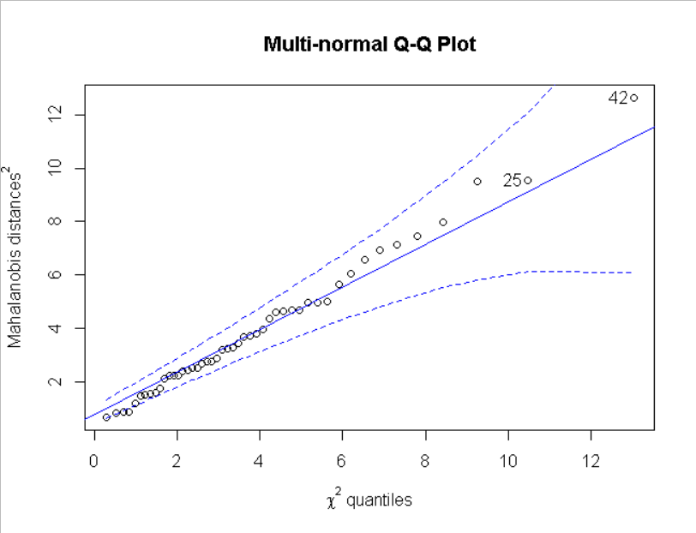

Given the small data size the dots to the right that do deviate aren’t significant enough to discredit a multivariate normal distribution of the residuals. To further confirm that we can use the MANOVA we tested that the variances are all from the same distribution I ran an M-box test that resulted in a p-value of 0.711, meaning we do expect these to have the same variances.

From here we ran a bootstrapping protocol in hopes of further supporting our previous tests. This provided a bootstrap lambda of 0, further supporting that these are not from the same mean distribution.

**Problem 2**

Using Principle Component Analysis (PCA) to predict variable 4 we get the following graph that shows how much more accurate we get with each additional PCA vector:

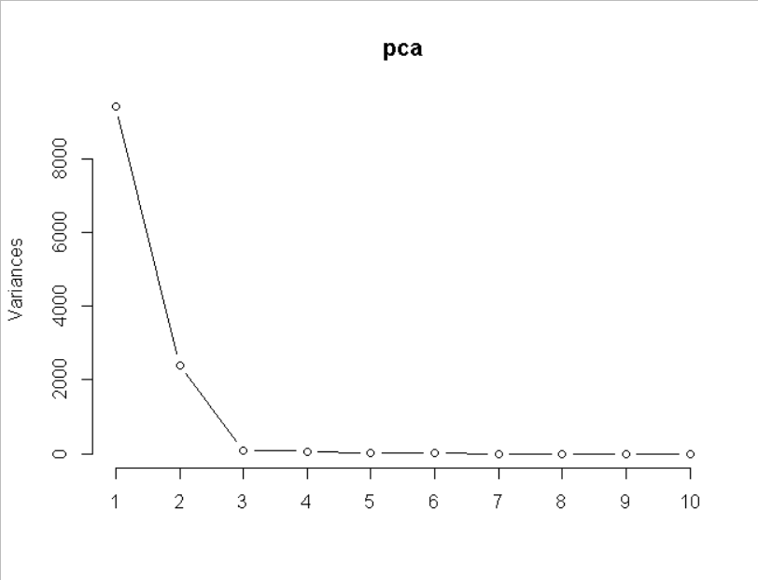

This suggest we should be using 2 vectors as the amount of information we get in additional vectors is near zero. Plotting every datapoint using the two principle components we get a graph where, by looking at the x and y axis labels, we can see 98.2% of the variance is explained with the two principle components:

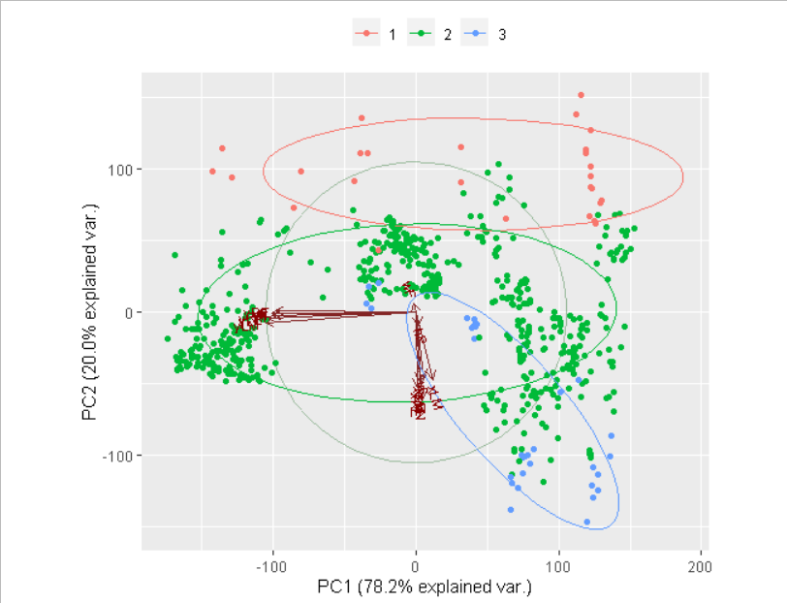

In this graph each color corresponds to a value in variable 4, the ovals are where a majority of the points can be found for each value, and the dark red vectors are each principle component. Comparing the above graph to the below graph which has only the first two principle components graphed (the two we decided we needed) we see nearly every other principle component is mapped virtually on top of the first two:

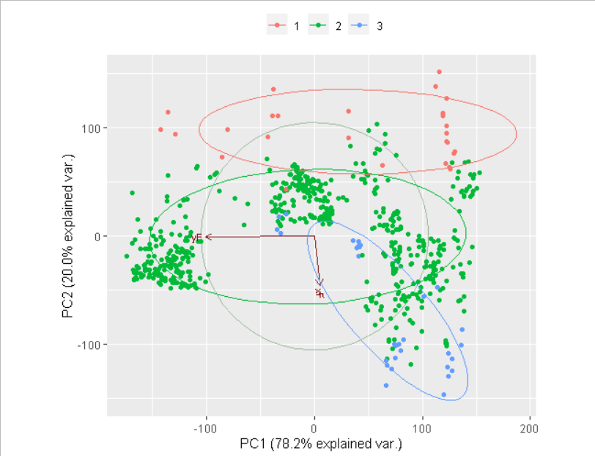

While PCA can be used to simplify the model and make prediction as a result, Factor Analysis can show us hidden connections we don’t realize are occurring. Thus, we analyzed the data using this method as well. Running the analysis with 9 factors, the max possible for the number of variables in the data set, we see that after factor 4 we do not have another factor with a value greater than 0.2. I re-ran the data with only 4 factors given the addition information I had gained running it with 9, this created an analysis where factor 1 and 2 were clearly very important; however, factor 3 and 4 both had at least one component at .842 indicated these were still important factors. Using the following graph we verified that 4 factors was indeed the best option.

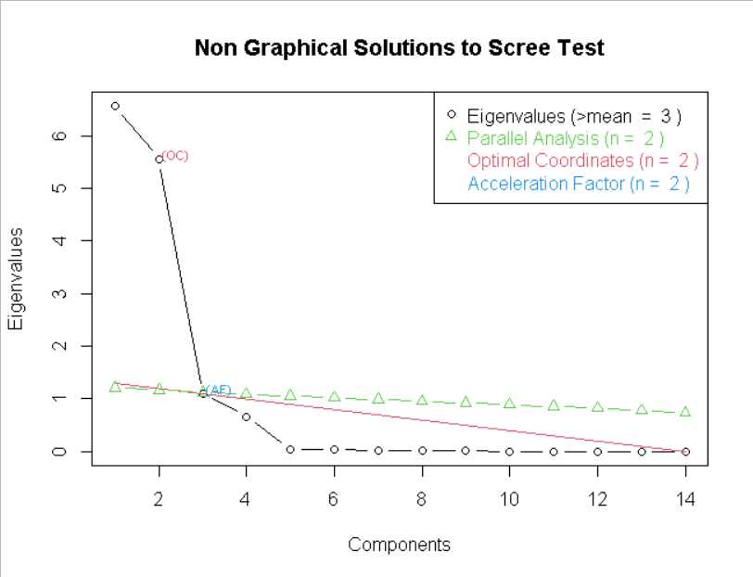

Appendix: Code

library(mvtnorm)  
library(RVAideMemoire)

## *** Package RVAideMemoire v 0.9-77 ***

library(rstatix)

##   
## Attaching package: 'rstatix'

## The following object is masked from 'package:stats':  
##   
## filter

library(mnormt)  
library(nFactors)

## Loading required package: lattice

##   
## Attaching package: 'nFactors'

## The following object is masked from 'package:lattice':  
##   
## parallel

setwd('C:\\Users\\User\\Desktop\\School\\Math_537\\Test2')  
data=read.table('Apple.txt', header=T)  
  
head(data)

## Rootstock y1 y2 y3 y4  
## 1 1 1.11 2.569 3.58 0.760  
## 2 1 1.19 2.928 3.75 0.821  
## 3 1 1.09 2.865 3.93 0.928  
## 4 1 1.25 3.844 3.94 1.009  
## 5 1 1.11 3.027 3.60 0.766  
## 6 1 1.08 2.336 3.51 0.726

######################################################  
#1 a)  
  
y=cbind(data$y1,data$y2,data$y3,data$y4)  
model=manova(y~as.factor(Rootstock),data=data)  
lam=summary.manova(model,test="Wilks")$stats[3]  
lam

## [1] 0.1540077

######################################################  
#1 b)  
  
temp=summary.manova(model,test="Wilks")  
temp$SS$Residuals

## [,1] [,2] [,3] [,4]  
## [1,] 0.3199875 1.696564 0.5540875 0.217140  
## [2,] 1.6965637 12.142790 4.3636125 2.110214  
## [3,] 0.5540875 4.363612 4.2908125 2.481656  
## [4,] 0.2171400 2.110214 2.4816562 1.722525

model$residuals

## [,1] [,2] [,3] [,4]  
## 1 -0.02750 -0.408125 -0.15875 -0.111125  
## 2 0.05250 -0.049125 0.01125 -0.050125  
## 3 -0.04750 -0.112125 0.19125 0.056875  
## 4 0.11250 0.866875 0.20125 0.137875  
## 5 -0.02750 0.049875 -0.13875 -0.105125  
## 6 -0.05750 -0.641125 -0.22875 -0.145125  
## 7 -0.02750 0.233875 0.24125 0.337875  
## 8 0.02250 0.059875 -0.11875 -0.121125  
## 9 -0.10750 -1.035125 -0.42500 -0.244500  
## 10 0.01250 -0.224125 -0.45500 -0.186500  
## 11 -0.04750 0.268875 0.35500 0.354500  
## 12 0.09250 0.796875 0.46500 0.236500  
## 13 0.01250 -0.327125 -0.13500 -0.083500  
## 14 -0.00750 -0.091125 0.13500 -0.036500  
## 15 0.01250 0.273875 0.17500 0.214500  
## 16 0.03250 0.337875 -0.11500 -0.254500  
## 17 -0.03750 -0.310250 -0.69500 -0.479375  
## 18 -0.11750 -0.500250 -0.01500 0.006625  
## 19 -0.04750 -0.148250 -0.07500 -0.194375  
## 20 -0.08750 -0.425250 0.21500 0.221625  
## 21 0.04250 0.205750 0.02500 0.084625  
## 22 0.09250 0.269750 0.32500 0.179625  
## 23 0.09250 0.492750 0.11500 0.114625  
## 24 0.06250 0.415750 0.10500 0.066625  
## 25 0.12250 -0.041750 -0.01625 -0.095000  
## 26 -0.06750 -0.528750 0.14375 0.202000  
## 27 0.04250 0.121250 0.14375 -0.016000  
## 28 -0.08750 -0.440750 0.01375 0.028000  
## 29 -0.10750 -0.680750 -0.63625 -0.346000  
## 30 0.01250 0.438250 0.04375 0.046000  
## 31 0.10250 0.721250 0.36375 0.203000  
## 32 -0.01750 0.411250 -0.05625 -0.022000  
## 33 -0.17000 -1.025250 -0.27250 -0.097000  
## 34 0.07000 -0.005250 -0.15250 -0.030000  
## 35 0.06000 0.525750 0.47750 0.200000  
## 36 -0.03000 -0.227250 0.10750 0.061000  
## 37 -0.09000 -0.478250 -0.84250 -0.508000  
## 38 0.14000 0.808750 0.09750 -0.044000  
## 39 -0.03000 -0.141250 0.32750 0.274000  
## 40 0.05000 0.542750 0.25750 0.144000  
## 41 0.07375 0.598375 0.16375 0.065000  
## 42 -0.28625 -1.374625 -0.45625 -0.129000  
## 43 0.01375 -0.015625 0.15375 0.055000  
## 44 -0.01625 -0.082625 0.39375 0.118000  
## 45 0.01375 -0.265625 -0.25625 -0.125000  
## 46 0.03375 0.036375 -0.38625 -0.173000  
## 47 0.09375 0.849375 0.03375 -0.028000  
## 48 0.07375 0.254375 0.35375 0.217000

mqqnorm(model$residuals)

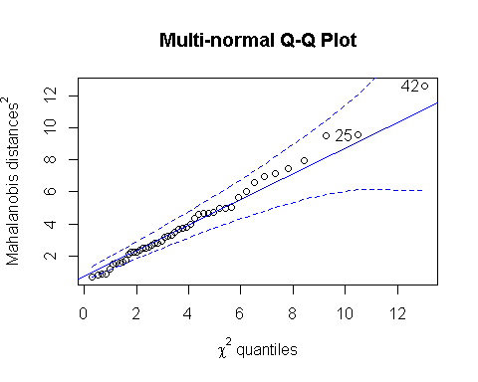

## [1] 42 25

#fairly normal  
  
  
box_m(y, data$Rootstock)

## # A tibble: 1 x 4  
## statistic p.value parameter method   
## <dbl> <dbl> <dbl> <chr>   
## 1 44.0 0.711 50 Box's M-test for Homogeneity of Covariance Matric~

# With a p-value of .711 this implies that each y_i came from similar variances.  
  
  
######################################################  
#1 c)  
  
n=10000  
lam2=matrix(0,1,n)  
  
data2=as.matrix(data)  
  
ind=sample(1:48,replace=T)  
final=cbind((data2[,1]),(data2[ind,2:5]))  
results= final[,2:5]  
y=cbind(final[,2],final[,3],final[,4],final[,5])  
model=manova(y~as.factor(final[,1]),data=as.data.frame(final))  
lam2[1]=summary.manova(model,test="Wilks")$stats[3]  
  
for(i in 2:n)  
{  
 ind=sample(1:48,replace=T)  
 final=cbind((data2[,1]),(data2[ind,2:5]))  
 results=results+final[,2:5]  
 y=cbind(final[,2],final[,3],final[,4],final[,5])  
 model=manova(y~as.factor(final[,1]),data=as.data.frame(final))  
 lam2[i]=summary.manova(model,test="Wilks")$stats[3]  
}  
  
sum(lam2<lam)/n

## [1] 0

results=results/n  
  
results=cbind((data2[,1]),results)  
y=cbind(results[,2],results[,3],results[,4],results[,5])  
model=manova(y~as.factor(results[,1]),data=as.data.frame(results))  
mqqnorm(model$residuals)

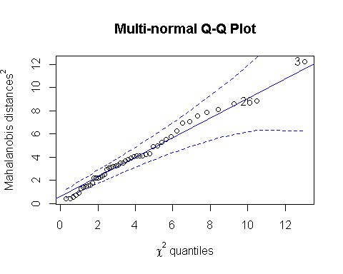

## [1] 3 26

######################################################  
#2 a)  
  
data2=read.table('drivPoints.txt', sep=",", header=T)  
  
data2F=scale(data2[,6:dim(data2)[2]],scale=F)  
  
pca = prcomp(data2F)  
pca

## Standard deviations (1, .., p=14):  
## [1] 96.989608 49.020727 9.624131 8.328001 4.206615 3.476437 2.617391  
## [8] 2.510391 1.937855 1.734361 1.621667 1.489140 1.224986 1.037106  
##   
## Rotation (n x k) = (14 x 14):  
## PC1 PC2 PC3 PC4 PC5 PC6  
## xF 0.022139210 -0.364691878 0.25895493 -0.548645238 0.039618288 -0.16728177  
## yF -0.405234308 -0.004778740 -0.26409687 -0.063828886 -0.024108922 -0.21234173  
## wF -0.005415327 0.048131327 0.14303311 0.767759768 0.181515296 -0.23689076  
## hF 0.009165877 -0.073678717 0.77630615 0.104973303 -0.042171033 0.42989565  
## xRE 0.004989021 -0.416446184 -0.10826090 0.018492764 0.251632361 0.22953706  
## yRE -0.393713598 0.006608796 -0.03590325 0.008890949 0.038302284 0.06596350  
## xLE 0.014991964 -0.399378853 0.08544017 0.019941142 0.314556678 -0.19500235  
## yLE -0.415892117 -0.031293068 -0.13671720 -0.005511949 0.223947416 0.24128765  
## xN 0.018698874 -0.487562171 -0.30072123 0.229893445 0.057778273 0.34210424  
## yN -0.405475548 -0.007788982 0.15285279 -0.019743770 0.362372110 0.04941103  
## xRM 0.011153666 -0.379847163 -0.12601406 0.164184853 -0.653772537 0.14944976  
## yRM -0.402354929 -0.021147988 0.18580243 0.053648042 -0.359204093 -0.16931529  
## xLM 0.048896923 -0.373292785 0.14299816 0.101111441 -0.001664671 -0.60097517  
## yLM -0.421652110 -0.058496574 0.12820531 0.017077591 -0.241118098 -0.03264033  
## PC7 PC8 PC9 PC10 PC11 PC12  
## xF 0.40491612 -0.33589079 0.33157585 -0.09590638 0.08240220 -0.22078009  
## yF -0.11704124 -0.05737643 0.32405676 -0.40915082 -0.53188154 0.36370552  
## wF 0.31735222 -0.36542852 0.17719603 -0.13047353 0.06369219 -0.08038808  
## hF -0.21461040 0.13603592 0.13139530 -0.25335383 -0.19443019 0.09321161  
## xRE 0.12138798 -0.10914983 -0.12095685 -0.17674548 0.36762451 0.62912712  
## yRE 0.08383014 0.19473543 0.05547406 -0.26257109 0.14851806 -0.41279575  
## xLE -0.40467679 -0.35098949 -0.37023166 0.15586806 -0.38526016 -0.20312112  
## yLE -0.20689352 -0.07460613 -0.18571629 -0.32753504 0.27539435 -0.32374509  
## xN -0.08718797 0.20064332 0.52304943 0.35787832 -0.08996423 -0.17686412  
## yN 0.51446644 0.32120677 -0.28163416 0.33918403 -0.28181877 0.10262474  
## xRM 0.30047412 -0.03691901 -0.41203819 -0.19909829 -0.20384079 -0.10348746  
## yRM -0.02933347 -0.03832200 0.14530317 0.29567071 0.06679623 0.05287241  
## xLM -0.15730543 0.57588955 -0.04397738 -0.15662530 0.23206093 0.01905817  
## yLM -0.24305524 -0.27447109 -0.03729036 0.34016760 0.31559282 0.18939995  
## PC13 PC14  
## xF -0.10970164 0.073477543  
## yF -0.10803058 -0.003552877  
## wF -0.06914370 0.026523228  
## hF -0.04143233 -0.001925596  
## xRE 0.29061840 -0.102728541  
## yRE 0.28845793 -0.667175639  
## xLE 0.19535238 -0.139401899  
## yLE -0.14222970 0.554921054  
## xN -0.08702378 0.042554583  
## yN -0.14530951 0.068836782  
## xRM -0.09530381 0.024390902  
## yRM 0.64366421 0.331878469  
## xLM -0.14985572 0.082970898  
## yLM -0.51885202 -0.294385271

plot(pca,type="l")

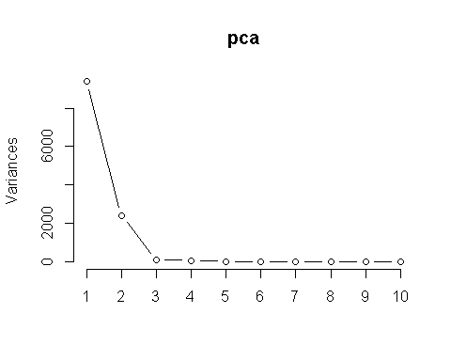

source("ggbiplot2.R")  
  
componet=pca$rotation[,1:2]  
  
#All principle components printed  
  
g = ggbiplot(pca, obs.scale = 1, var.scale = 1,   
 groups = as.factor(data2[,4]), ellipse = TRUE,  
 circle = TRUE)

##   
## Attaching package: 'plyr'

## The following objects are masked from 'package:rstatix':  
##   
## desc, mutate

g <- g + scale_color_discrete(name = '')  
g <- g + theme(legend.direction = 'horizontal',   
 legend.position = 'top')  
g

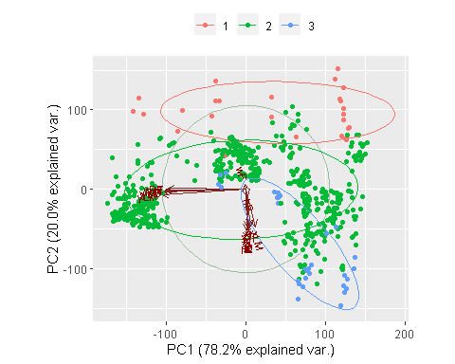

#Only the first two principle componenets printed (important ones)  
  
g = ggbiplot(pca, obs.scale = 1, var.scale = 1,   
 groups = as.factor(data2[,4]), ellipse = TRUE,  
 circle = TRUE,numComp=2)  
g <- g + scale_color_discrete(name = '')  
g <- g + theme(legend.direction = 'horizontal',   
 legend.position = 'top')  
g

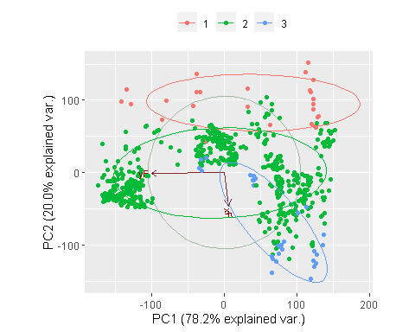

head(data2)

## fileName subject imgNum label ang xF yF wF hF xRE yRE xLE  
## 1 20130529_01_Driv_001_f 1 1 2 0 292 209 100 112 323 232 367  
## 2 20130529_01_Driv_002_f 1 2 2 0 286 200 109 128 324 235 366  
## 3 20130529_01_Driv_003_f 1 3 2 0 290 204 105 121 325 240 367  
## 4 20130529_01_Driv_004_f 1 4 2 0 287 202 112 118 325 230 369  
## 5 20130529_01_Driv_005_f 1 5 2 0 290 193 104 119 325 224 366  
## 6 20130529_01_Driv_006_f 1 6 2 0 290 204 105 118 324 231 368  
## yLE xN yN xRM yRM xLM yLM  
## 1 231 353 254 332 278 361 278  
## 2 235 353 258 333 281 361 281  
## 3 239 351 260 334 282 362 282  
## 4 230 353 253 335 274 362 275  
## 5 225 353 244 333 268 363 268  
## 6 232 351 253 335 277 362 276

######################################################  
#2 b)  
  
X=data2F  
  
f1=factanal(data2F,factors=9,rotation="varimax")  
  
f2=factanal(data2F,factors=4,rotation="varimax")  
  
ev <- eigen(cor(X)) # get eigenvalues  
ap <- parallel(subject=nrow(X),var=ncol(X),  
 rep=100,cent=.05)  
nS <- nScree(x=ev$values, aparallel=ap$eigen$qevpea)  
plotnScree(nS)

